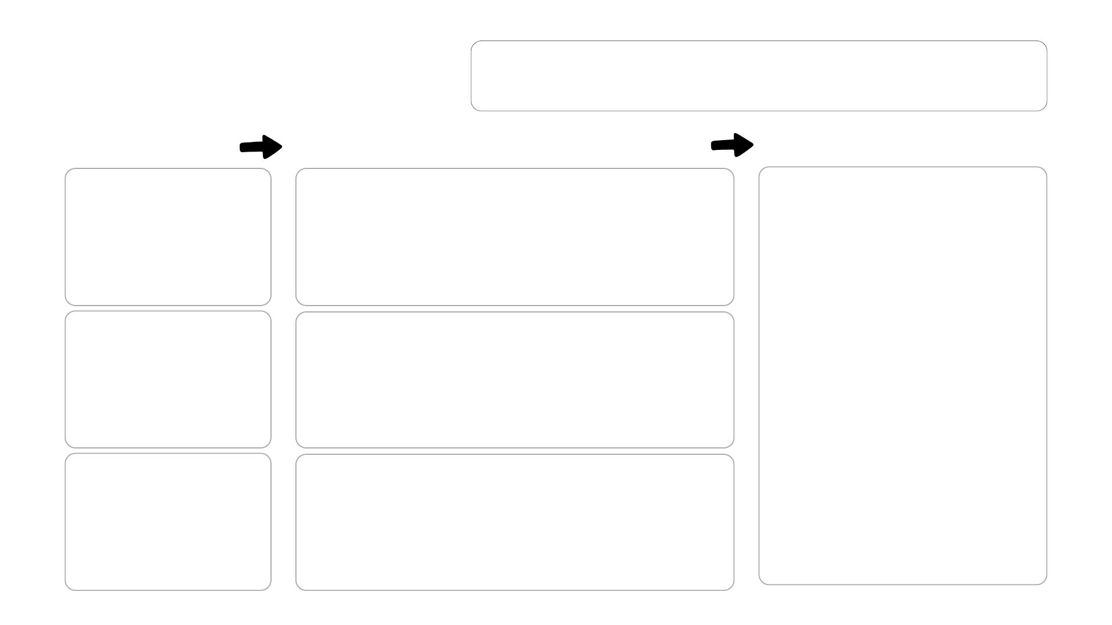
Transformed task description:

Original task
description:

Inquiry
question:

Application:

Key strategy:

Brainstorming/ideas:

K

U

S

ORIGINAL TASK
CRITICAL & CREATIVE THINKING STRATEGIES
TRANSFORMED TASK
Outcomes
Application/task

